The Squirrel Saga - November 2019

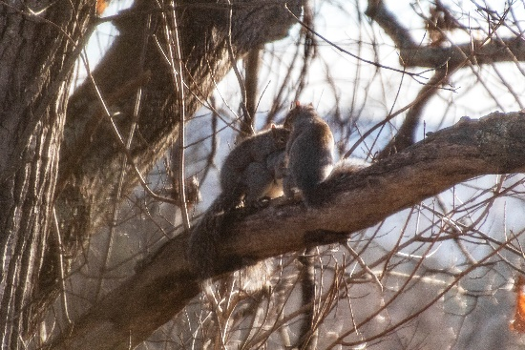It occurred on this Sunday morning, November 17, 2019.   
We had just finished our morning 2-miler and breakfast and had moved onto our Sunday morning exercise routines in the upper den. As we began with the bands and weights facing East, we noticed that there was a tad of squirrel activity in the outside large old oak trees. On one lower branch, a solitary squirrel roamed. Just above, there were two squirrel tails under one “?” squirrel. As it unfolded the “1” became 2. One was calmly sitting on the limb while the other was attacking his/her back munching on sap/blood/scotch – and all was peaceful! Then the squirrel on the lower branch entered the activity and now two squirrels were feasting on the one’s back. On it went. One squirrel left. A 4th entered and began prtaking on the one’s back. A paw-fight erupted. Munching returned. After a lot of tasting or whatever, all 4 moved ran away to do whatever squuirrels do on a Sunday morning.

The photos were taken at 300mm through the wglass window and micro-screen.

And for the photos, click [Squirrel Saga 2019](https://photos.app.goo.gl/YktiS3UrtPR5Q5yH8).